WEEK 6

Mandatory Hands-On

**REACT**

**Create a new CSS Module in a file called “CohortDetails.module.css”**

1. **Understanding the need for styling react component**

Styling improves the **visual appearance** and **usability** of React components. It helps in maintaining a **consistent UI design** across the application. Styles make components more **interactive** and user-friendly. Well-structured styling ensures **separation of concerns** between logic and presentation. It allows developers to **customize components** based on props, themes, or screen size.

1. **Working with CSS Module and inline styles CSS Modules** scope styles locally to components, preventing style conflicts. You can import a .module.css file and apply styles using className={styles.className}. **Inline styles** allow dynamic styling using JavaScript objects. Use inline styles for **conditional rendering** (e.g., change color based on status). Combining both approaches gives flexibility in managing styles efficiently.

* Unzipped the react application in the directory Week6\ React\ cohorttraker.
* Restored the node packages using  *npm install* command.

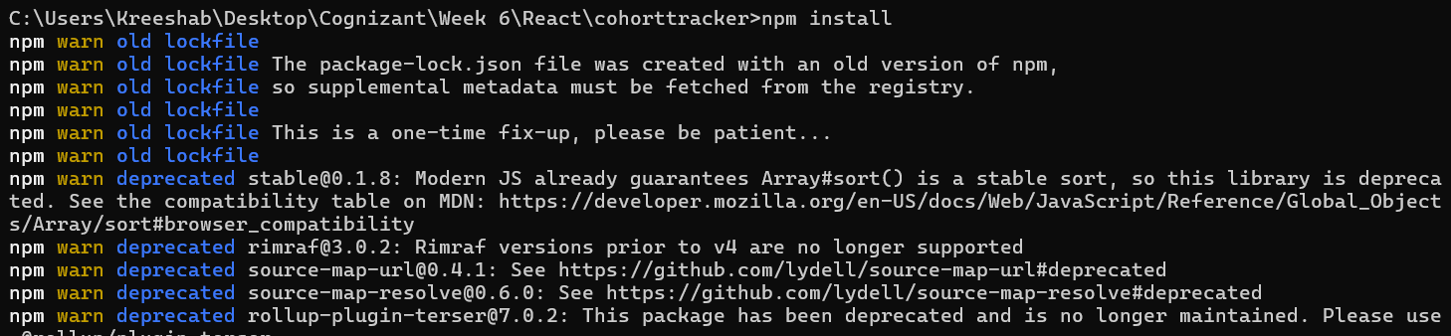

* Navigated to the react app and created CSS module in a file called “CohortDetails.module.css”.

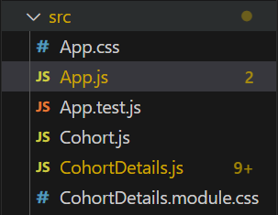

**CohortDetails.module.css:**

.box {

  width: 300px;

  display: inline-block;

  margin: 10px;

  padding: 10px 20px;

  border: 1px solid black;

  border-radius: 10px;

}

dt {

  font-weight: 500;

}

**CohortDetails.js:**

import styles from './CohortDetails.module.css';

function CohortDetails(props) {

    const h3Style = {

        color: props.cohort.currentStatus === 'ongoing' ? 'green' : 'blue'

    };

    return (

        <div className={styles.box}>

            <h3 style={h3Style}>

                {props.cohort.cohortCode} -

                <span>{props.cohort.technology}</span>

            </h3>

            <dl>

                <dt>Started On</dt>

                <dd>{props.cohort.startDate}</dd>

                <dt>Current Status</dt>

                <dd>{props.cohort.currentStatus}</dd>

                <dt>Coach</dt>

                <dd>{props.cohort.coachName}</dd>

                <dt>Trainer</dt>

                <dd>{props.cohort.trainerName}</dd>

            </dl>

        </div>

    );

}

export default CohortDetails;

**App.js:**

import logo from './logo.svg';

import './App.css';

import { CohortsData} from './Cohort'

import CohortDetails from './CohortDetails';

function App() {

  return (

  <div>

    <h1>Cohorts Details</h1>

    {CohortsData.map(cohort => <CohortDetails cohort={cohort}/>)}

  </div>

  );

}

export default App;

**Sample Output:**

